 | Diagnostic Medicare Center Management  Technical Design Document
 | Prepared By / Last Updated By | Reviewed By | Approved By
Name | Shiv Pratap Mishra
Role | Individual
Signature
Date | 20/12/2019

Table of Contents

1.0 Introduction 3
1.1 Purpose of this document 3
1.2 Project overview 3
2.0 Solution Summary 3
2.1 Scope 3
2.2 Assumptions 3
2.3 Dependencies 3
2.4 Risks 3
3.0 Schematic Diagram 3
4.0 System Design 4
4.1 Proposed design 4
4.2 Component inventory 4
5.0 Database Design 4
5.1 Data Model 4
5.2 Tables Structure 4
6.0 Appendices 4
6.1 Glossary 4
6.2 Other 5
7.0 Terms & Conditions 5
8.0 Change Log 5

Introduction

Purpose of this document
The purpose of this document is to document the technical design, component details and Database design. This will also capture the scope, assumptions, risk, dependencies of this project.

Project overview
Diagnostic Medicare is a portal for the patients and agents to book appointments for various medical services and gives authority to admin and doctor to approve, reject appointments.

Solution Summary

Scope
Our project’s scope includes services like appointment booking, availing medical services and get medical reports. The admin can approve, reject or modify doctor, patient and agent. Similarly doctor can approve, reject or modify patient and agent. Patient and agent can book appointments, view medical test report and provide feedback.

Assumptions
We assume the following while development of our project:
- There are multiple admins.
- There can be multiple doctors
- There can be multiple patients
- There can be multiple agents

Dependencies
There are no dependencies related to our project the technologies we used in our project are the ones we were trained on.

Risks
None as of now.

Schematic Diagram
Admin home:
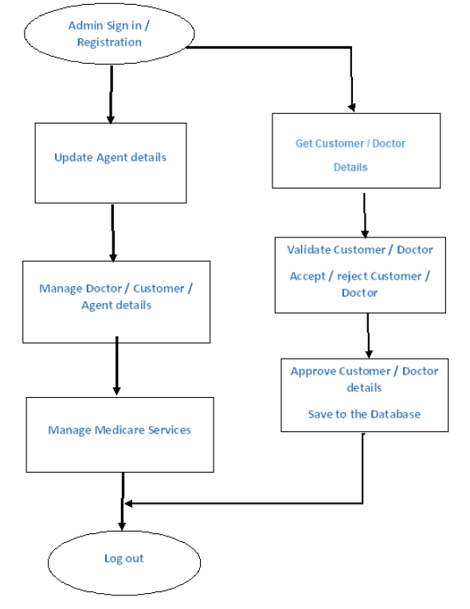
Doctor Home:

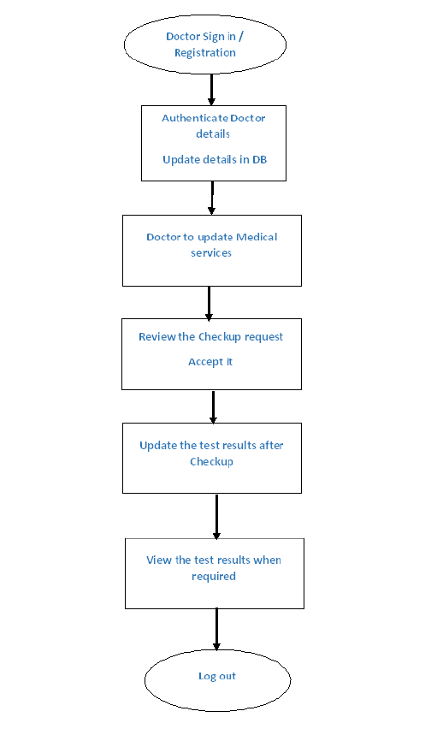
Patient/Agent Home:
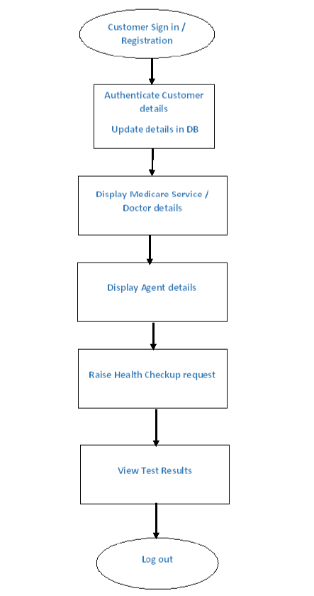

System Design

Proposed design
Below are the design objectives that shall be fulfilled post the execution of this project:
- Role based registration & credential authentication
- Appointment booking by patient and agent
- Appointment approval/denial by admin or doctor
- View appointment status by patient and agent
- Update Test result by admin or doctor
- View test result by patient and agent
- Provide feedback by patient and agent

Component inventory
High level component breakdown:
- Admin component
- Doctor component
- Patient component
- Agent component
- Login/signup component
- Appointment component
- Medical test component
- Feedback component

Database Design

Data Model
Database includes various tables and their interdependencies with one another which can be seen in the below table structure.
The tables include:
- User table: Includes username, password and admin/doctor/patient/agent id
- Role table: Includes name of the role and id of the role which is the primary key of the table
- Admin table: : Includes all details of admin
- Doctor table: : Includes all details of doctor
- Patient table: : Includes all details of patient
- Agent table: : Includes all details of agent
- Medicare service table: Includes name of service, description of service and cost of service.
- Appointment table: Includes patient name, appointment date, booking date, doctor id, user id
- Medical test table: It includes the details of all the tests
- Feedback table: It stores all the answers to the questions submitted by patient and agent.

Tables Structure
Table name: user
Primary key: us_id
Foreign key: us_ad_id, us_dc_id, us_pt_id, us_ag_id

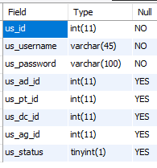

Table name: role
Primary key: ro_id

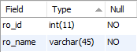

Table name: admin
Primary key: ad_id
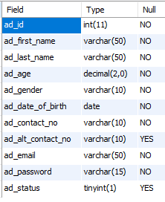

Table name: doctor
Primary key: dc_id
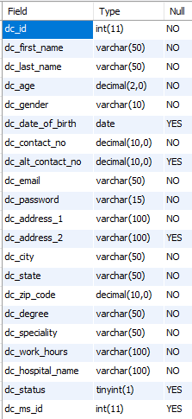

Table name: patient
Primary key: pt_id
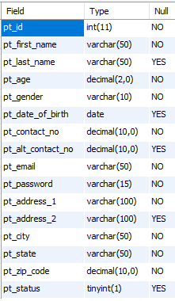
Table name: agent
Primary key: ag_id
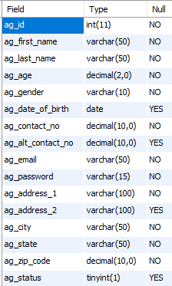
Table name: appointment
Primary key: ap_id
Foreign key: - ap_dc_id, ap_us_id
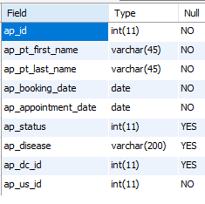
Table name: medical test history
Primary key: mt_report_id
Foreign key: mt_doctor_id, mt_ms_id, mt_us_id, mt_ap_id
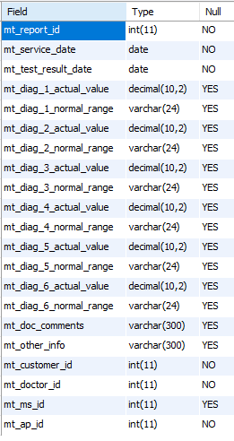

Table name: feedback
Primary key: fb_ass_id
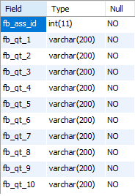
Table name: user feedback
Primary key: ufb_ass_id
Foreign key: -ufb_us_id, ufb_dc_id , ufb_ap_id
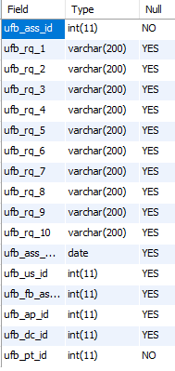

Table name: medicare services
Primary key: ms_id
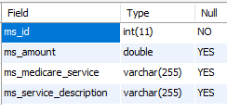

Appendices

Glossary
Acronyms | Definitions
null | null

Other

Terms & Conditions
Interns shall be solely responsible for all its acts and omissions under this program. Interns will comply at all times with all applicable laws. Interns shall not use Cognizant’s name, logo and trademark in any promotional materials or other communications with third parties without the prior written consent of Cognizant. Any materials used by interns in relation to program will not infringe the copyrights, trademarks, patents, trade secrets or other intellectual property rights, privacy or similar rights of any person or entity. Interns agrees not to post, draw, make, display any content that is threatening, libelous, obscene, defamatory, abusive, pornographic, or advocates/encourages any conduct that could constitute a criminal offence or give rise to any civil liability. Cognizant its associates’ personal details including but not limited to name, address, contact number shall not be shared or forwarded to any third party, without prior written consent of Cognizant, its associates. All intellectual property provided by Cognizant, as part of program shall be owned exclusively by Cognizant. Intern shall indemnify, defend and indemnify Cognizant its associates, officers, directors from and against any claims, demands, loss, damage, liability, causes of action, judgments, or costs and expenses of every nature (including attorney’s fees and expenses) incurred by Cognizant based on any claim that any breach of terms and conditions of this program

Change Log
Please note that this table needs to be maintained even if a Configuration Management tool is used.
Version Number | Changes made
V<n.n> | <If the change details are not explicitly documented in the table below, reference should be provided here>
V<n.n> | Page no | Changed by | Effective date | Changes effected
V<n.n> | All | Shiv Pratap Mishra | 20/12/2019 | Final update

